**Exercise 4**

1. Draw a simple UML diagram representing a class hierarchy with inheritance in java.

|  |
| --- |
| **Animals** |
| **Weight**  **Breed**  **Age**  **Size** |

|  |
| --- |
| Goat |
| +get Weight()  +get Breed()  +get Age()  +get Size() |

|  |
| --- |
| Cow |
| +get Weight()  +get Breed()  +get Age()  +get Size() |

|  |
| --- |
| Rhino |
| +get Weight()  +get Breed()  +get Age()  +get Size() |

|  |
| --- |
| Buffalo |
| +get Weight()  +get Breed()  +get Age()  +get Size() |

1. **Java code with loop to print all even numbers between 1 and 200.**

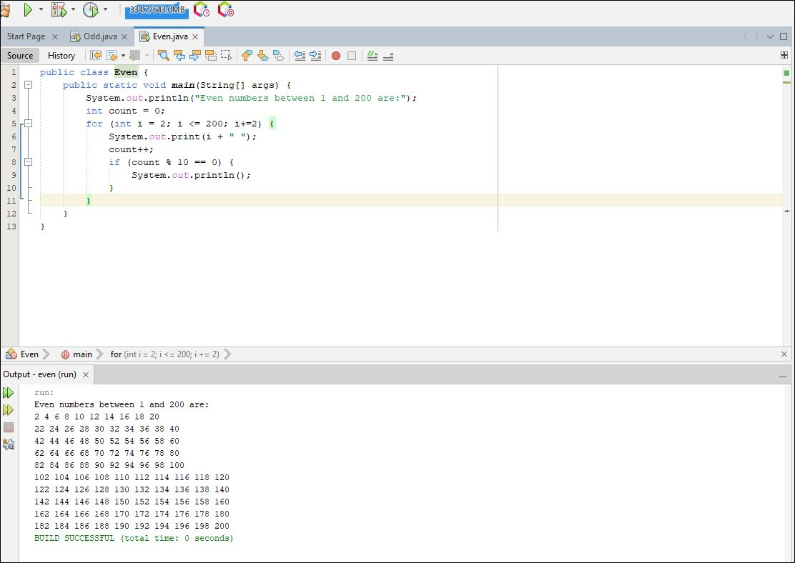

1. Java code with loop to print all odd numbers between 1 and 50.

